

Complex Computing Problem / Complex Computing Activity (CCP/CCA)

Instructor: Amir Parre

Student Name: |  | Sufwan Amir  Sharia Noor
Registration No: |  | FA23-BDS-063  FA23-BDS-036
Course: |  | Web Technologies

  - COMSATS University Islamabad

Title: Distributed Ride-Sharing Web Platform with Real-Time Trip Services (GaariYaari )
Problem Context
You are hired as a full-stack engineer to design and implement GaariYaari, a scalable ride-sharing web platform where drivers can post trips and passengers can book seats in real-time. The system must support:
- High concurrency when multiple users search/post/book rides
- Microservices-based architecture
- Real-time updates (ride availability, seat count)
- Secure APIs and optimized database operations
- Future capability for authentication, payments, and analytics

1. Problem Statement
Design and develop a full-stack distributed web application (MERN stack with Node.js backend) for GaariYaari, supporting the following functionalities:
• User Management System
- Authentication (JWT) + Role-Based Access Control
(Driver / Passenger / Admin roles)
- Session management & refresh tokens
- Multi-step registration (profile details, CNIC verification optional)
• Trip Posting & Ride Management Microservice
- CRUD operations for trips:
  - Pickup location
  - Destination
  - Date & time
  - Available seats
  - Cost per seat
- Driver profile integration
- Ride status updates (available → booked → completed)
• Real-Time Booking & Seat Management
- Real-time seat updates using WebSockets (Socket.IO)
- Intelligent seat recalculation when multiple users book instantly
- Notification events:
  - “Seat booked”
  - “Ride full”
  - “Ride cancelled”
• Ride Booking/Order Workflow
- Event-driven architecture
- Booking lifecycle tracking
(Requested → Confirmed → Ongoing → Completed)
- Transaction safety while reserving seats
- Handling double-booking race conditions
• Admin Panel for Analytics (GaariYaari Admin Dashboard)
- Dashboard with charts
- Real-time metrics:
  - Rides posted today
  - Total active users
  - Most popular routes
  - System load / real-time events

2. Activity Requirements

A. Design Phase

• Create System Architecture Diagrams
High-Level Architecture of GaariYaari
- Shows interaction between Client (HTML/CSS/JS), API Gateway, Microservices, Database, and Real-Time Server.
Microservices Interaction Diagram
- Auth Service
- Ride (Trip) Service
- Booking Service
- Admin Service
- Optional: Notification Service
Database ERD for:
- User
- Trip
- Booking
- Payments
- Vehicle
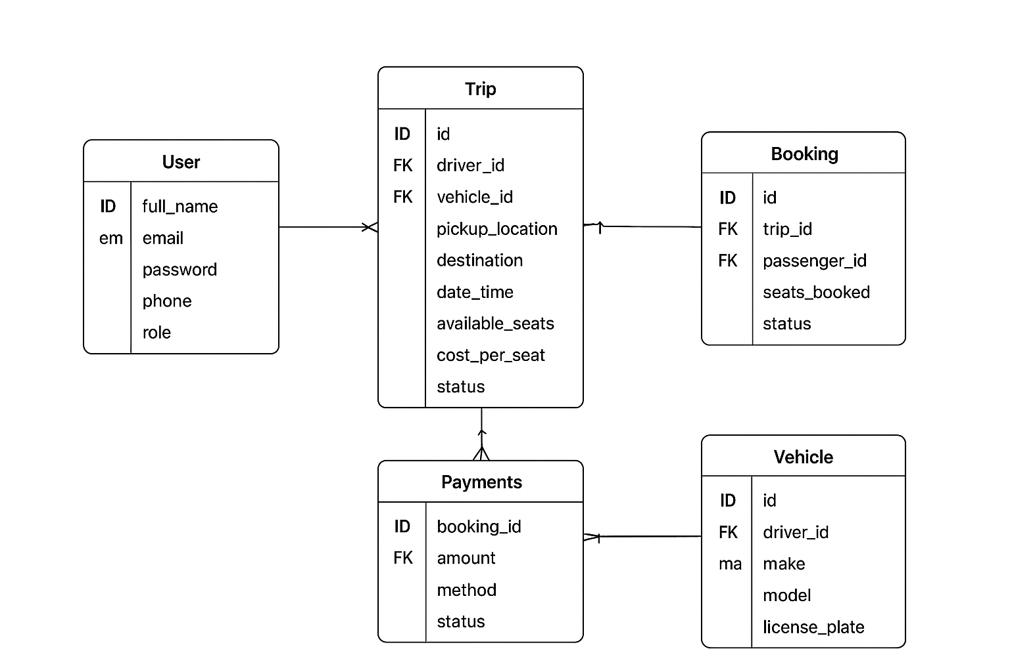
API Gateway Routing Structure
- Gateway routes incoming client requests to the appropriate microservice:
  - /auth/* → Auth Service
  - /trips/* → Ride Service
  - /booking/* → Booking Service
  - /admin/* → Admin Service

• Define REST API Specifications
Examples:
- POST /auth/signup – Register a new user (driver/passenger).
- POST /auth/login – Authenticate user and return JWT.
- POST /trips/create – Driver posts a new ride.
- GET /trips/search?pickup=&destination=&date= – Passenger searches rides.
- POST /booking/confirm – Reserve seats for a selected trip.
- Additional endpoints for:
  - Trip management
  - Booking management
  - Admin analytics

• Select and Configure Your Technology Stack
Frontend:
- HTML
- CSS
- JavaScript (Vanilla JS)
Backend:
- Node.js
- Express.js
- Socket.IO (real-time events)
- Mongoose
Database:
- MongoDB (Cloud: MongoDB Atlas)
Architecture Pattern:
- Microservices
- REST APIs
- Event-driven booking notifications

B. Implementation Phase

Backend Implementation

• Implement Modular Express Routers
- /auth – Signup, login, JWT token handling
- /trips – Trip creation, update, search APIs
- /booking – Seat reservation and booking management
- /admin – Data analytics APIs

• Create Secure JWT Authentication
- Issue JWT on login
- Verify token on protected routes
- Role-based access control (driver / passenger / admin)

• Build Microservice Modules
User Service
- Register/login users
- Manage driver/passenger profiles
Trip Service
- Drivers post rides
- Manage seat availability
- Search & filter rides
Booking Service
- Handle booking requests
- Prevent double-booking
- Update seat counts
Admin Service
- Analytics (popular routes, total users, ride statistics)
- Aggregated queries using MongoDB pipelines

• Real-Time Communication
Using Socket.IO, implement:
- Live updates to seat availability
- Instant notification when:
  - A booking is confirmed
  - A ride becomes full
  - Trip status changes

• Additional Backend Requirements
- Input validation using Joi / Zod
- Rate limiting to protect API
- Apply CORS rules
- Use MongoDB aggregation for:
  - Popular pickup routes
  - Peak booking hours
  - Total trips and users

Frontend Implementation

• Build a Responsive Client Interface Using HTML/CSS/JS
Pages include:
- Home page
- Trip posting page (Driver)
- Ride search page (Passenger)
- Booking confirmation page
- Basic admin overview page

• JavaScript Functionalities
- Form validation
- Fetch API calls to backend
- Dynamic rendering of search results
- Real-time updates using Socket.IO
- Display trip/seat changes instantly

C. Integration & Deployment Phase

• Create a Reverse Proxy Using NGINX
- Route traffic to backend microservices
- Serve static frontend files
- Secure routes and load-balance (optional)

• Deploy Backend & Frontend Using Docker Containers
- Container for API Gateway
- Containers for each microservice
- Container for Socket.IO real-time server
- Container for frontend static hosting

• Connect to Cloud-Hosted MongoDB Atlas
- Secure connection string
- Environment-based configuration

• Configure Environment Variables Securely
In .env files:
- JWT_SECRET
- MONGO_DB_URI
- PORT
- API keys (if used)
- Socket.IO server URL

3. Complexity Criteria (Aligned with CCP/CCA Requirements)
- Multiple technologies: Node.js, React, MongoDB, Socket.IO
- High-level abstraction → microservices + distributed communication
- Data-intensive operations → rides, route filtering, real-time seat counts
- Complex user interaction → real-time bookings, notifications, dashboards
- Deployment → Docker, NGINX, cloud database
- Security → JWT, RBAC, input sanitization

4. Expected Deliverables
- Technical Documentation (PDF)
- System architecture diagrams
- Source Code (GitHub repo)
- Deployed URL (or Docker images)
- API documentation (Swagger/Postman)
- Final report + presentation

